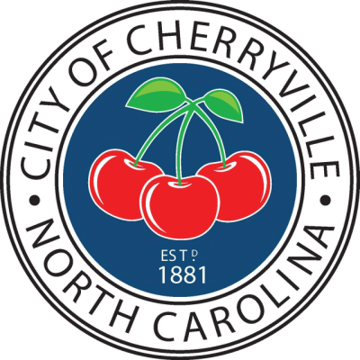
The City Council Work Session
meeting for
Tuesday April 27, 2021
has been cancelled.
If you have any questions
please contact Paige Green
City Clerk at 704-435-1709.

